**Nexus Setup**

**This is on Prod Server**

1. Create a deployment file nexus-deployment.yaml

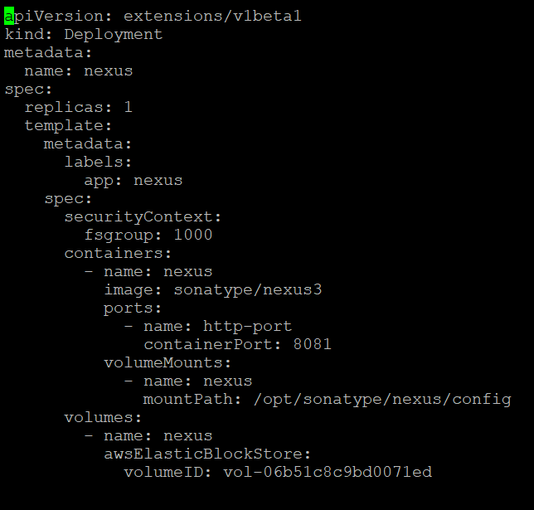

1. Create a service file nexus-service.yaml

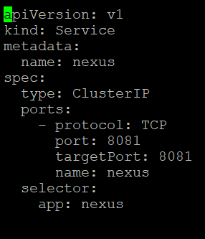

1. Create a persistence volume yaml pv-volume.yaml

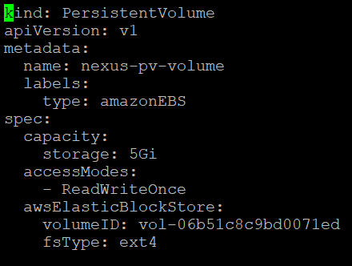

1. Create a persitance volume claim yaml pvc.yaml

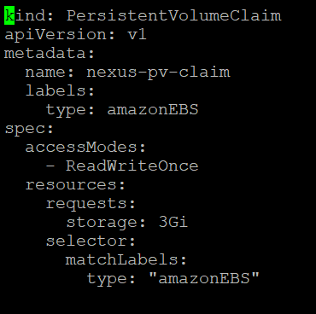

1. To apply the yaml files use command kubectl apply –f <FILE NAME>
2. To check the pv claims use command kubectl get pv | grep nexus
3. To check all the components running related to nexus use the following command:

kubectl get all | grep nexus

**Output:**

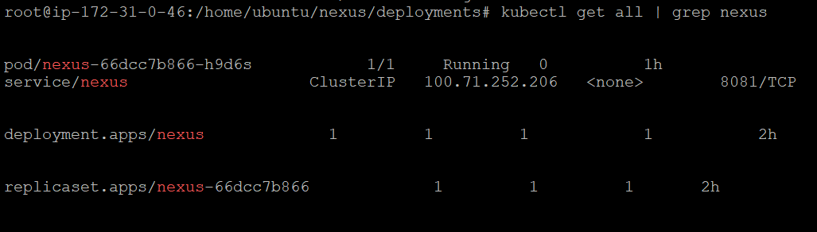

1. Also, all these files are present on the production server on the path /home/ubuntu/nexus/deployments
2. Nexus URL: <http://actlabinnovation.digitalcloudplatform.com/>
3. Nexus Version: 3.29.2-02

Since this went down on 03rd Feb 2021, new was created by Aishwarya

Below is the command I used to bring up nexus container:

docker run -d -p 8081:8081 --name nexus -v /home/ubuntu/nexus:/nexus-data sonatype/nexus3

Apart from this, I did nothing. [@Nachimuthu, Devarajan](mailto:devarajan.nachimuthu@capgemini.com) you can add it in the document.

<http://54.77.227.5:8081/>

admin

nexusuer@123#